**CHAPTER III**

**METHODOLOGY**

This chapter presents the system design and methodology of the researchers’ system.

**SYSTEM DEVELOPMENT LIFE CYCLE (SDLC)**

System Development Life Cycle is a methodology that produces a software with a lower cost but highest quality in the shortest time possible (Alvater, 2021). It provides a framework for a standard set of activities and deliverables. It is also the evolution of making decisions and plans to produce software that will provide outreach to the client, as well as guidelines for well-maintained software.

The Software Development Life Cycle is a framework that defines the tasks that must be completed at each stage of the software development process. The development team follows this structure.

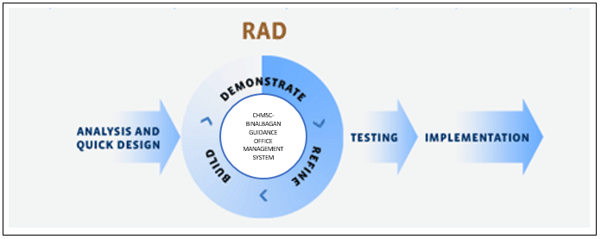

*Figure 1 (RAD) Rapid Application Development Model*

Figure 1 shows the Rapid Application Development Model that is used by the researchers as their model for the system. It shows how the research and process is being implemented from the start of the process until it has been finished.

**Phases of** **(RAD)** **RAPID APPLICATION DEVELOPMENT MODEL**

**Analysis and Quick Design**

The researchers conducted a virtual pre-interview to the present and previous Coordinator of the NSTP. The researchers asked for their way in managing the students’ information and grades, the enrollment process and the attendance of the students. The researchers found out that the they are using a manual system in enrollment and attendance. The students’ grades are saved through Microsoft Excel. After the interview, the researchers conducted a thorough analysis on how to automate the process of managing the records of the CHMSC Binalbagan NSTP Office and then the researchers identified a platform to be used for the development of the system.

**Build**

The researchers started building the prototype of the system with different features and functions. The researchers also do the coding and test some errors.

**Demonstrate**

The researchers will demonstrate the fully-developed system to the users. The researchers will teach and guide them on how to use the system. The researchers will show them the step-by-step process for them to fully understand and use the system easily and efficiently.

**Refine**

The researchers will refine the system if there will be changes needed. The researchers will improve their ideas and will make some changes to make it more efficient and functional system. The researchers will base those ideas from its users.

**Testing and Implementation**

The researchers will conduct a testing for them to know that the system is reliable and is ready to use. If the system is really ready for use, the researchers will have the implementation of the NSTP Management System to the NSTP Office of Carlos Hilado Memorial State College- Binalbagan Campus.

**Respondents of the Study**

Table 1: Summary of the Respondents

|  |  |
| --- | --- |
| **Respondents** | **No**. |
| IT Experts | 5 |
| End-Users (NSTP Coordinator, NSTP Instructors, Students) | 29 |
| Total | 34 |

*Table 1:* Participants of the Study

Table 1 shows the classification of evaluators and the corresponding number of evaluators per classification. Five Experts and Four End-Users/Clients.

**Research Instrument**

The researchers will conduct a survey to the NSTP Coordinator and instructors to determine their evaluation of the CHMSC Binalbagan NSTP Management System. The researchers will use the Post Study System Usability Questionnaire (PSSUQ) as the survey questionnaire. The researchers will give them enough time to answer the survey.

**Data-gathering Procedure**

To gather relevant data and information, the researchers constructed questions for the pre-interview. The researcher’s conducted a virtual pre-interview to the NSTP Coordinator. The researchers also conducted a pre-interview to the previous NSTP Coordinator. Based on the gathered information, the researchers were able to identify the problems the office is facing and the requirements needed in designing the proposed system.

**Data Analysis**

After collecting all the survey forms, the researchers will use an appropriate descriptive statistical tool. The researchers will utilize the mean to determine the users’ collective ratings.

The frequency and percentages were included to determine the demographic profile of the respondents with the formula:

1(n) + 2(n) + 3(n) + 4(n) + 5(n) N

Where,

n = number of respondents’ result

N = the total number of respondents

In interpreting the derived weight mean, the hypothetical range with interpretation was applied.

|  |  |
| --- | --- |
| Verbal Interpretation | Range of Mean Score |
| Very Useful  Useful  Moderately Useful  Less Useful  Least Useful | 1.00-2.19  2.20-3.39  3.40-4.59  4.60-5.79  5.80-7.00 |

*Table 2: Verbal Interpretation*

Table 2 shows the verbal interpretation of the evaluated system and its range of mean score.

**Context Diagram**

The Context Diagram shows the relationship that the system has with other external entities. It also shows the general input requirements and its processed output.

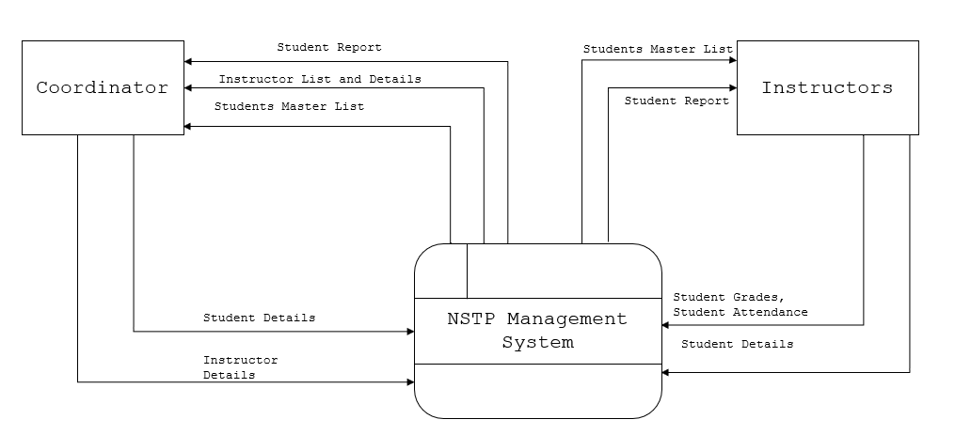

*Figure 2:* Context Diagram of the CHMSC Binalbagan NSTP Management System

Figure 2 shows the general processes of the developed system. It also demonstrates the input requirements needed to be filled-up by the Admin/Instructor and the expected processed output from the system.

**Data Flow Diagram**

The Data Flow Diagram of the proposed system shows the graphical visualization of the movement of data through the system. It also shows the processes with data flowing into and out of each process.

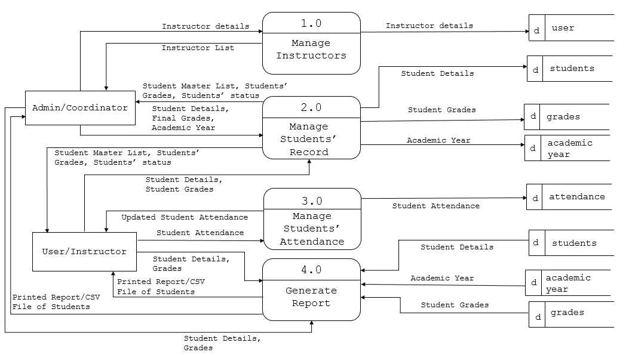

*Figure 3:* Data Flow of the CHMSC Binalbagan NSTP Management System

Figure 3 shows the Data Flow Diagram of the CHMSC Binalbagan NSTP Management System. It also shows the flow of the output and input of each entity and the process. Inputs and outputs of the data are being stored and retrieved in the database including all information needed for the system to execute the process.

**Use Case Diagram**

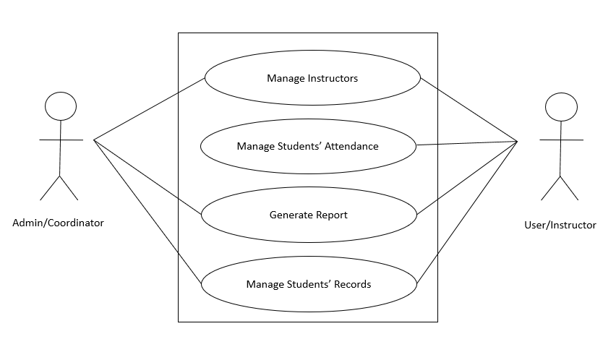

*Figure 4*: Use Case Diagram of CHMSC Binalbagan NSTP Management System

This use case model is used to show the interaction of the admin and instructor and the system.

Figure 4 shows the major tasks that actors must do in order to implement the system.

Manage Instructors

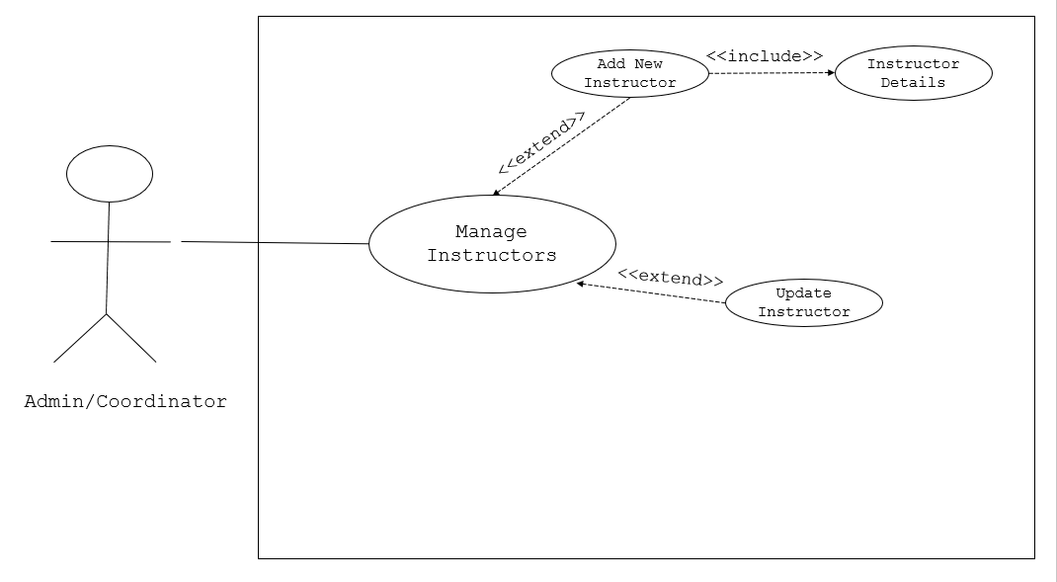

Figure 4.1: Manage Instructors Use Case Diagram

Figure 4.1 shows how the information flows and how the admin/coordinator manage instructors.

Manage Students’ Attendance

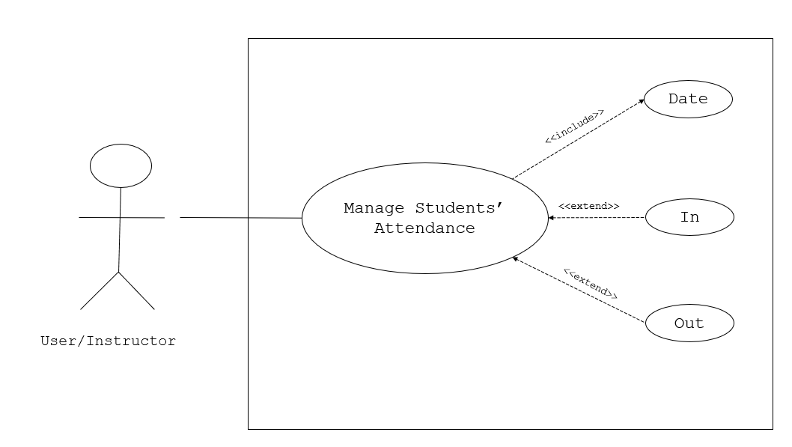

Figure 4.2: Manage Students’ Attendance Use Case Diagram

Figure 4.2 shows how the information flows and how the user/instructor manage students’ attendance.

Generate Report

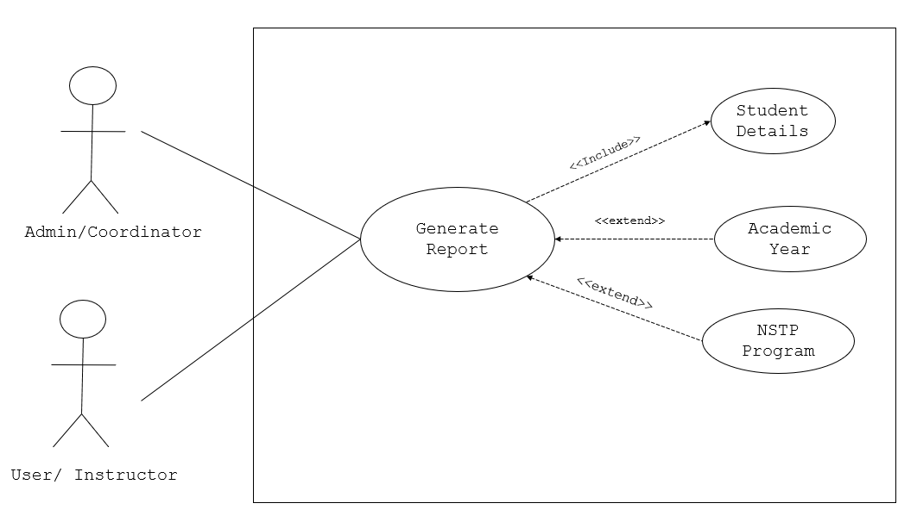

Figure 4.3: Generate Report Use Case Diagram

Figure 4.3 shows how the information flows and how the admin/coordinator and user/instructor generate report.

Manage Students’ Records

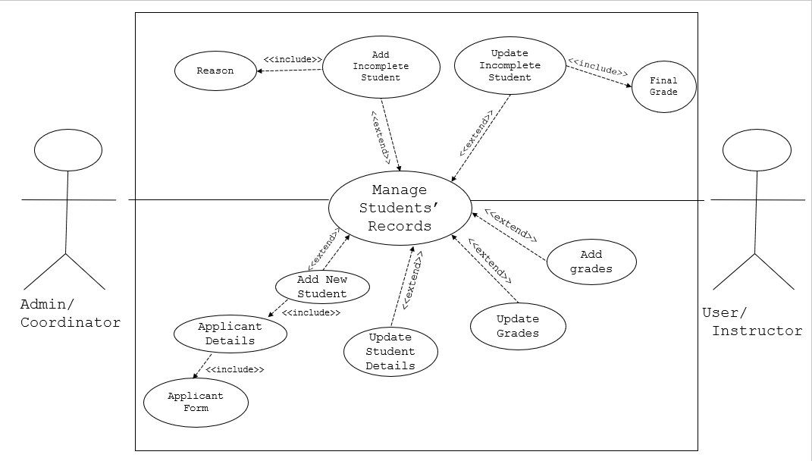

Figure 4.4: Manage Students’ Records Use Case Diagram

Figure 4.1 shows how the information flows and how the admin/coordinator and user/instructor manage students’ records.

**Activity Diagrams**

Manage Instructors

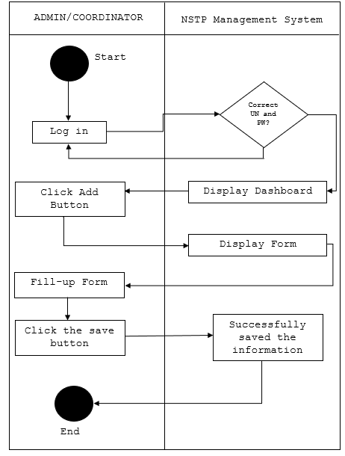

Manage Students’ Attendance

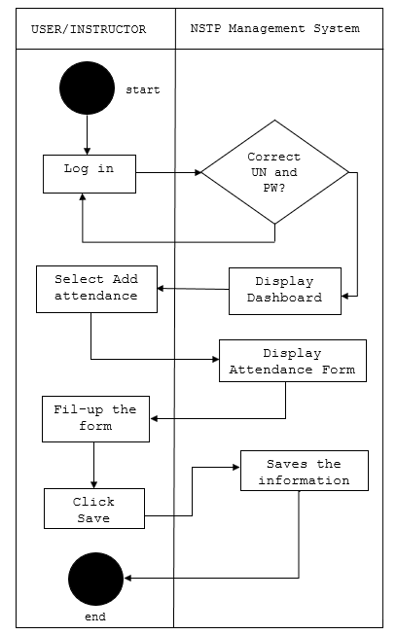

Generate Report

**Entity Relationship Diagram**

